There is a luggage-storage depot on the upper level of the underground parkade, near the main lift lobby in International Arrivals. You may leave any baggage at a cost of R50.00 per item for the first day and R40.00 per item every day thereafter. Mastercard and Visa accepted. Open 24 hours 7 days a week

Official porters have ACSA authorised permits and wear bright orange uniforms.

Tip R5/bag

First Class Curbside Check-in
SAA's new First Class concierge-style curbside check-in facility takes care of travelers' baggage while SAA hostesses escort customers through a fast-track immigration channel, directly to the nearby First Class lounge
International Arrivals Lounge (JIA)
This facility is for the exclusive use of our First Class, Business Class and Platinum and Gold Cardholders, and offers exceptional facilities, such as luxurious showers, an array of cold breakfast items, and high-tech business equipment. It is located on the Mezzanine level in the Arrivals Terminal. (As you exit the Customs area it is on the right hand side on the Mezzanine area.)
Cycad Premium Lounge (First Class – JIA)
The Cycad Premium Lounge in JIA is situated on the upper-mezzanine level (airside) of the International Departures Terminal. The lounge has a chef and team of waiters on duty seven days a week and offers a range of sophisticated dining options and a full bar service. Other facilities include five luxurious shower rooms, a soundproof reading room, a smoking room, and five soundproof snooze rooms with CD players. It also features a state of the art business centre with nternational telephone, computer and Internet facilities.
Arrivals Lounge in London
Located on the domestic departures level, in Terminal 1, it is for the use of our First Class, Business Class and Platinum Cardholders. This facility offers showers and a business centre. Enjoy a hot breakfast, and have your clothes steamed while you shower. Pure luxury!

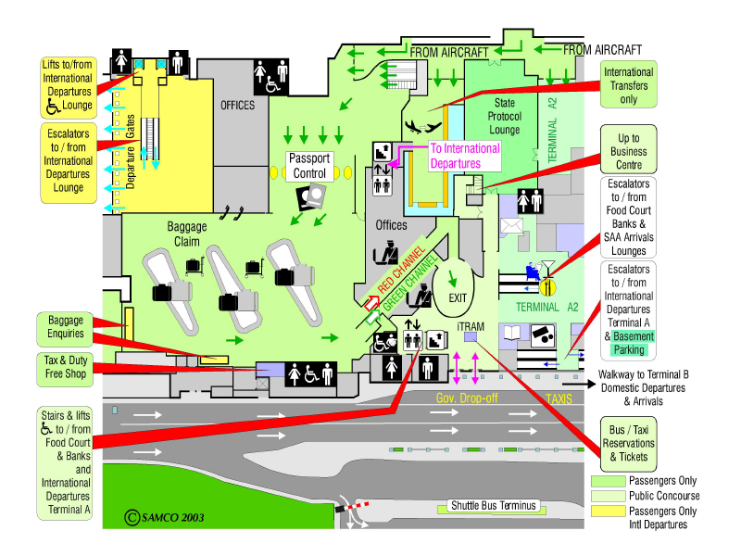
International Arrivals A1I

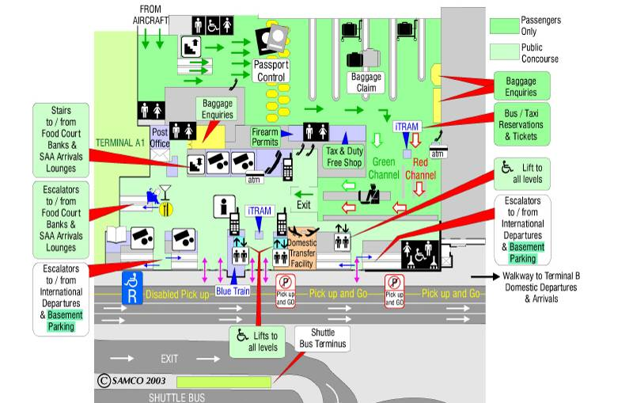
International Arrivals A2I
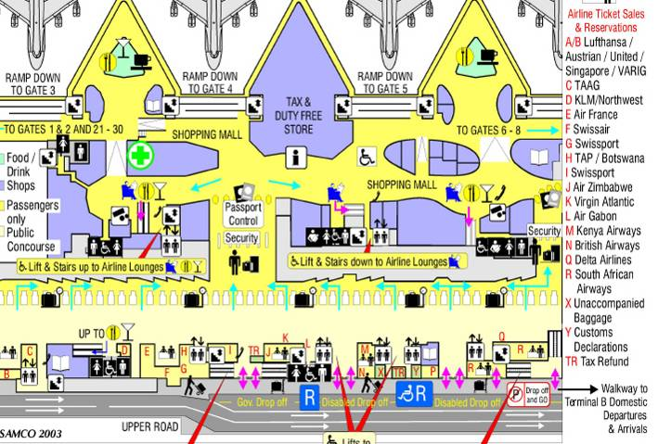
International Departures

